Update on Innovation Landscape and Strategy
Introduction
The announcement of the UK Innovation Strategy in the last few weeks alongside the policy focus on levelling-up and the need for growth in the wake of Covid, sets the course for the governments direction on innovation and effectively replaces the previous National Industrial Strategy. This paper sets out the key elements of our local plans to date and the alignment issues with national thinking requiring consideration.
Background
The current Lancashire Innovation Plan was developed in 2017 to align with the previous governments emerging National Industrial Strategy with a strong emphasis on innovation as a driver of productivity, noting both the region and county lagging behind in productivity.
It provided a route map for innovation and the evidence base for five strategic aims with the objective to set a direction of travel with a strong partnership approach and an Innovation Board.
It did however emphasise the need to be flexible and indicated that global change may require updates to the approach and it recognised the need for deeper dives as the Innovation Board developed. The five strategic aims are set out in the diagram below:
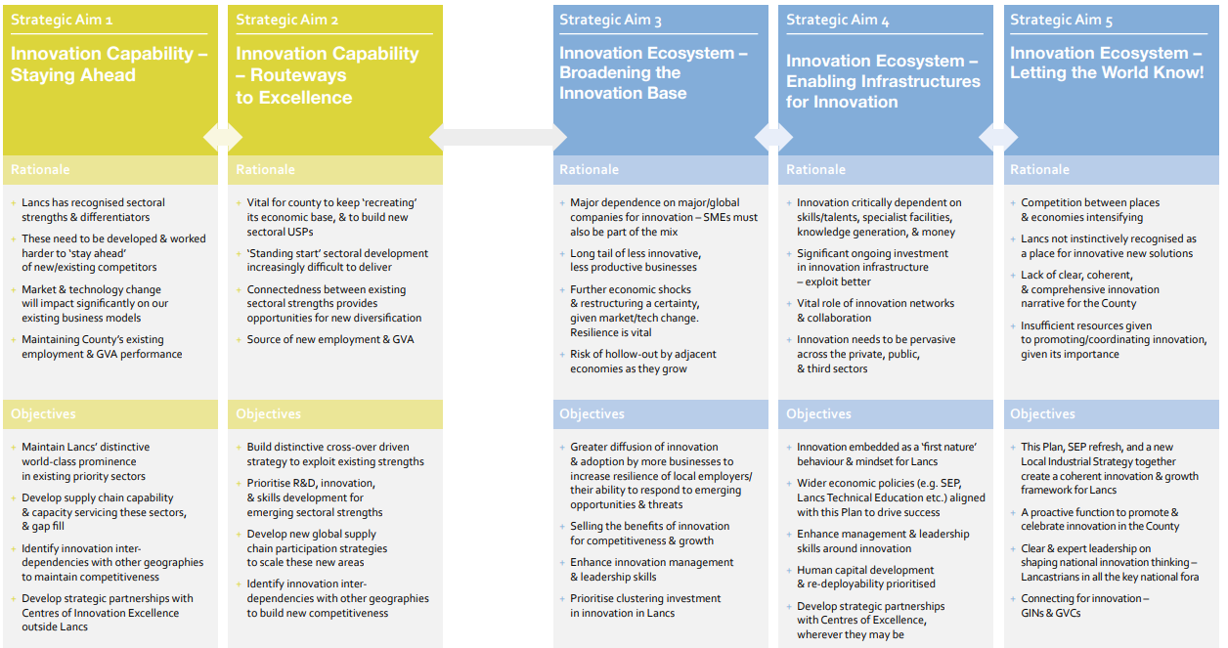
The counties overall Strategic Economic Plan had set in motion key investments in innovation Assets but similar change was anticipated in light of Brexit, Covid and the Levelling-Up policy emphasis. In response the LEP developed a Strategic Framework providing a business voice for growth, building on input from key sector groups.
The LEP Sector Groups are developing headline sector plans and priorities that will in turn inform and require responsive cluster developments. The strategic framework raises the importance of innovation alongside identification of the enablers and technologies that cut across the our strong sectors in Lancashire.
The diagram below illustrates the LEP Sector Group pillars of growth and framework of enablers.
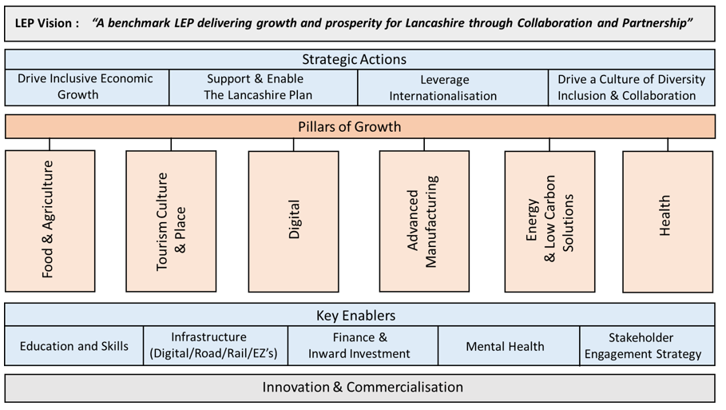
In light of this the work on a Lancashire Local Industrial Strategy (LIS), supported by Steer Consultancy, was updated on the basis of the Strategic Framework and new policy directions to inform the development of a Lancashire Growth Plan.
This recent work has also rationalised and combined our innovation planning and evidence base to align the sector groups and emerging clusters, identify four missions that build on our strengths and national challenges and three themes for what we must “own”, collaborate on or adopt. This unifying LEP Innovation Strategy is illustrated in the following diagram and also shows the recently published UK Innovation Strategy technology families:
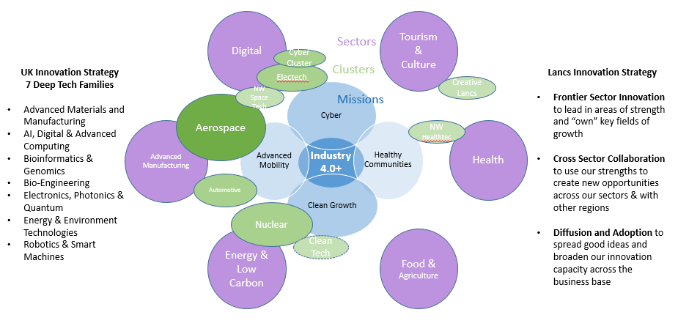
In terms of this innovation landscape and strategy the questions for stakeholders in Lancashire include the following considerations:
- What aspects and sub themes of the UK Innovation Strategy technology families do we want to focus on that align with our strengths and capabilities?
- What do we know about the make-up of our clusters, their relative strengths and the support they need to meet their ambitions for innovation and place based R&D?
- How do the elements of the big missions we face as a society (locally and nationally) mesh with the technology families we want to focus on with our clusters and sector groups?
- What innovation do we want to own or lead on as our frontier sectors; what do we want to collaborate on across sectors/regions; what do we want to adopt and diffuse across our business base?
This emergent LEP Innovation Strategy is designed to build on our strengths and offer alignment to the contents of the UK Innovation Strategy described below, which will place a strong emphasis on our relationship with Innovate UK and UKRI to co-create propositions in Lancashire.

The UK Innovation Strategy
Published in the last few weeks, this document sets out the government’s interest in supporting innovation in Places, Sectors and Business with an emphasis on levelling up the economy, creating high value jobs and global trading opportunities. At various stages the interlinking of these factors is stressed and it is seen in the light of the importance of infrastructure, skills and innovation as key drivers and sets out to boost private sector investment. It commits to increasing public spend on R&D which have been echoed by Treasury statements at the time of its release.
Importantly the UK plan states that it has asked Innovate UK and UKRI to inform on the detail and operationalise the strategy.
In summary the Strategy divides its actions into four pillars as follows:
Pillar 1 – Unleash Business – the focus being priming with increased public R&D and the setting up of an on-line finance and Innovation Hub linked to Innovate UK Edge. It advises it will consult on regulation that hinders innovation and form a national Business Innovation Forum. It proposes to build on lessons from the rapid team Covid R&D response. Links to Catapults, the use of Test Beds, importance of safe data and the better use of venture funding are cited.
Pillar 2 – People – Efforts will be made to build on visa changes to attract the best innovators and entrepreneurs and the Help to Grow: Management programme was re-announced. In Lancashire, Lancaster University and UCLan will be in a position to deliver Help to Grow. The strategy announced a consultation later in the year on setting up a hub or hubs for Cyber-Physical Infrastructure
Pillar 3 – Institutions and Places – The Govt has proposed to review/map the organisations doing innovation and support place based innovation projects. It re-announces money previously committed to Strength in Places and proposes to expand the Connecting Capability Fund programme. Reference is made to better access or regional support through UKRI and a commitment that more Places will host world-leading, globally connected innovation Clusters/Hubs. Innovation Districts are cited as examples of place based approaches and the concept of Innovation Deals may be expected regionally. The Govt plan is that Shared Prosperity Fund (SPF) plans will be announced later in the year
Pillar 4 – Missions & Technologies – the strategy says it will set up an Innovation Missions Programme linking to 7 key technologies and proposes new Prosperity Partnerships. The Strategy stresses that innovation is driven by responding to challenges (eg Covid) and being in a position to utilise emerging key technologies and proposes a more active approach.
There will therefore be an Innovation Missions Programme which will link science, industry, investment and world trade and new missions and priorities will be set by a new National Science and Technology Council. It is proposed that,
• efforts should be cross-sectoral and leverage transformational technologies,
• build on ISCF funding for projects (similarities to the Grand Challenges);
• cross fertilise human and physical sciences;
• make use of Govt convening power to facilitate a whole systems approach

The UK Innovation Strategy also sets out seven Tech families based on previous and updated work (eg 8 great tech that informed the Grand Challenges) and is meant to be areas the UK can secure advantage, as follows:
• Advanced materials and manufacturing
• AI, digital and Advanced computing
• Bioinformatics and Genomics
• Engineering Biology
• Electronics, Photonics and Quantum
• Energy and Environment Technologies
• Robotics and Smart machines

The integration of these families into a Cyber-Physical Infrastructure is also likely to be key. The document also advises that Government role is to help better access to specialist facilities for business and more finance support for Deep Tech and the strategy also announced:
• Importance of the EPSRC Prosperity Partnerships and inferring a new or widening role
• Further mention was made of a “future national capability in Cyber-Physical Infrastructure to
promote interoperability of tech tools and platforms”
• The Govt will establish a new Business Innovation forum
• The Govt will create an Office for Science and Technology Strategy.
• There will be focus on high growth sectors with sector visions
• The Govt will publish a National Cyber Strategy in the next 12 months

Way Forward
Further development of the LEP Innovation Strategy will feed into the process of refreshing the Lancashire Innovation Plan as well as help the Board to position cluster-based deals that respond to the UK Innovation Strategy. It is envisaged this will lead to developing a detailed action plan and co-creating propositions for key locations in the LEP geography.
A separate paper will be presented on the Innovation Plan refresh followed by two workshops being arranged for board members so that the wider issues can be incorporated into a new action plan.

